VEHICLE RENTAL BOOKING SYSTEM
@CREATIVITY THINK (9483175986/7019689991)

ABSTRACT:
Vehicle Rental Booking System is a web application that simplifies vehicle rental operations for individuals and businesses. Users can browse available vehicles, book rentals, make payments, and monitor usage history through an interactive dashboard. Administrators manage vehicle listings, review bookings, analyze rental data, and send notifications for updates or promotions. Developed using Django and Django Rest Framework for the backend, and React, Redux, and Recharts for the frontend, the system offers a secure, centralized platform for booking, tracking, and analytics, improving operational efficiency and customer satisfaction..

INTRODUCTION OF THE PROJECT:
Vehicle rental businesses require a streamlined approach to manage fleet availability, bookings, and payments. This platform centralizes these functions into a single web application, allowing users to easily search and book vehicles while tracking rental history. Administrators can efficiently manage vehicles, oversee bookings, and generate analytics reports for business insights. Built with Django, DRF, React, Redux, and Recharts, the system ensures secure, scalable, and user-friendly interfaces, supporting both operational and analytical needs of rental businesses..

PROJECT OBJECTIVES:

• Enable users to search, browse, and book vehicles online
• Provide secure payment processing for rental transactions
• Track rental history and usage statistics for users
• Allow administrators to manage vehicle listings and booking status
• Generate analytics dashboards for operational insights
• Send notifications for booking updates and promotions
• Improve efficiency of vehicle rental operations
• Facilitate decision-making through comprehensive data analysis

PROBLEM OF THE STATEMENT:
Traditional vehicle rental management often involves manual tracking of vehicles, bookings, and payments, resulting in inefficiencies, errors, and poor customer experience. Users struggle to view availability in real time, and administrators face challenges in maintaining records and analyzing usage trends. This project addresses these issues by providing a digital platform for booking, payment, history tracking, and analytics, enhancing both user convenience and administrative oversight..

MOTIVATION OF THE PROJECT:
• Simplify vehicle rental booking process for users
• Reduce manual record-keeping and operational errors
• Provide administrators with a centralized management system
• Enable real-time tracking of bookings and vehicle usage
• Support data-driven decision-making with analytics dashboards

BLOCK DAIGRAM OF PROJECT:

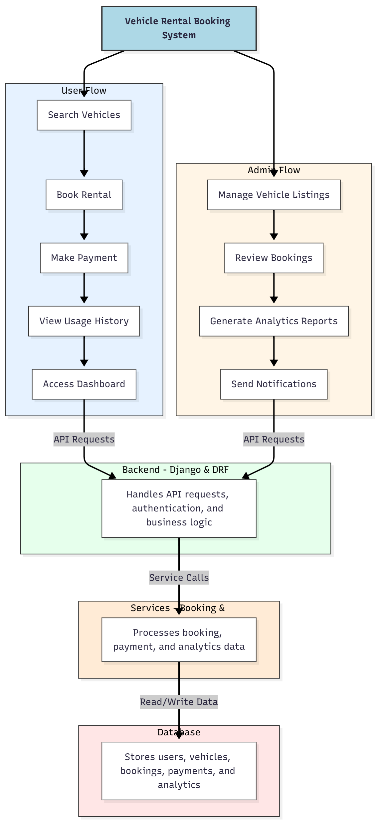

WORKING OF THE PROJECT:
Users log in and search for available vehicles, select desired options, and complete the booking process with secure payment. They can access their usage history and dashboard for insights into rentals. The backend handles authentication, API requests, and business logic, while services process booking transactions and analytics data. Administrators manage vehicle listings, review bookings, generate analytics reports, and send notifications for updates or promotions, ensuring a smooth, centralized rental management process..

SOFTWARE REQUIREMENT:
- Backend:
  - Python 3.x
  - Django
  - Django REST Framework
  - SQLite/PostgreSQL
- Frontend:
  - Node.js and npm
  - React.js
  - Axios
- Development Tools:
  - Visual Studio Code
  - Postman (for testing APIs)
  - Git/GitHub (for version control)
- Server/Deployment (Optional):
  - Gunicorn, Nginx, or Heroku/AWS for hosting

ADVANTAGES OF THE PROJECT:

• Simplifies vehicle rental operations for users and admins
• Secure and efficient booking and payment system
• Centralized management of vehicle listings and bookings
• Real-time rental history and usage tracking
• Notifications to keep users informed of updates
• Analytical dashboards for administrators
• Reduces operational errors and manual processes
• Scalable for different rental business sizes

APPLICATIONS OF THE PROJECT:
• Vehicle rental businesses
• Travel and tourism agencies
• Logistics and transport services
• Fleet management companies
• Corporate vehicle booking
• Car/bike rental startups
• Short-term vehicle rentals for events
• Data-driven operational optimization

REFERENCES:

- Django REST Framework Documentation — Django Software Foundation. Django Documentation. Available: https://docs.djangoproject.com/
- Django REST Framework. DRF Documentation. Available: https://www.django-rest-framework.org/
- React. React Official Documentation. Available: https://reactjs.org/docs/getting-started.html
- Redux. Redux Documentation. Available: https://redux.js.org/introduction/getting-started
- PostgreSQL Global Development Group. PostgreSQL Documentation. Available: https://www.postgresql.org/docs/
- MySQL. MySQL Reference Manual. Available: https://dev.mysql.com/doc/
- Git. Git Documentation. Available: https://git-scm.com/doc
- Node.js. Node.js Documentation. Available: https://nodejs.org/en/docs/
- Axios. Axios Documentation. Available: https://axios-http.com/docs/intro
- Socket.io Documentation – https://socket.io/docs/

